**“COSY AIR-CONDITIONERS”**

**“Sharp”**

**“Models”**

**“Sharp AH-XP10NRV”**

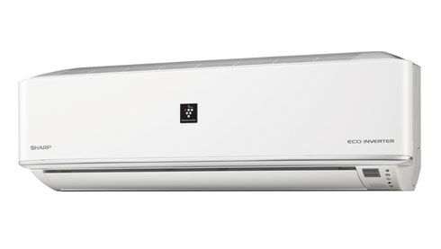

**FEATURES**

* Air Conditioner with inverter technology & Plasmacluster technology,
* Plamacluster ions - High density 7000 which clean the room air powerfully and quickly.
* Super Jet - Powerful, strong airflow blowing vigorously downwards.
* Gentle Cooling Mode cools the room gently without direct blow of cold dry air to the body, comfortable for baby & elderly.
* Instant low wattage function, it can select low power operation for energy saving .
* Sleep mode alternates On and Off during off-timer operation, so that it makes comfortable cooling while sleeping. This function work with off timer.
* **Specifications**
* **Inverter Controlled Operation**
* Yes
* **Power Input - Cool (W)**
* 890
* **Running Current - Cool (A)**
* 4.3
* **Voltage Range (V)**
* 198-264
* **Refrigerant**
* R410A

**RS ~ 47,500.**

**“Sharp AH-XP18MV”**

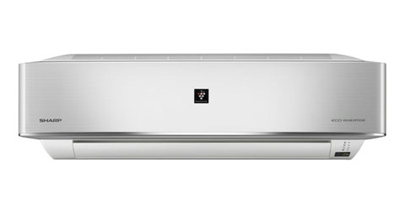

**FEATURES**

* Air Conditioner with inverter technology & Plasmacluster technology,
* Plamacluster ions - High density 7000 which clean the room air powerfully and quickly.
* Powerful Jet Stream cools a room and your body quickly.
* Gentle Cooling Mode cools the room gently without direct blow of cold dry air to the body, comfortable for baby & elderly.
* Instant low wattage function, it can select low power operation for energy saving .
* **Specifications**
* **Inverter Controlled Operation**
* Yes
* **Power Input - Cool (W)**
* 1440
* **Running Current - Cool (A)**
* 7.0
* **Voltage Range (V)**
* 220-240
* **Refrigerant**
* R410A

**RS ~ 89,000.**

**“Sharp AH-AP24MMV”**

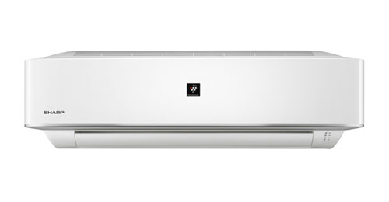

**FEATURES**

* Plamacluster ions - High density 7000 which clean the room air powerfully and quickly.
* Powerful Jet Stream cools a room and your body quickly.
* Gentle Cooling Mode cools the room gently without direct blow of cold dry air to the body, comfortable for baby & elderly.
* Instant low wattage function, it can select low power operation for energy saving .
* **Specifications**
* **Power Input - Cool (W)**
* 2400-2500
* **Running Current - Cool (A)**
* 11.5-11.3
* **Voltage Range (V)**
* 198-264
* **Refrigerant**
* R22

**RS ~ 79,000.**